!! NOTE COMPETITION CHANGES FOR 2026!!
2026 Kingswood Salver and Lanes Trophy
Saturday 14th November 2026
Judging and afternoon Talk at
Stover Country Park, Newton Abbot, TQ12 6QG

10.30 am for 11.00 am Start  Talk 2.00 pm - Close 4.30 pm | Awards for Best Panels &  Best Individual Prints
Closing Date for Entries 10th October 2026
Entry Fee £15 for the Kingswood Salver and £5 for the Lanes Trophy payable to WCPF. Bank details are
Sort Code 40-34-39 Account 31158139 - Ref Club Name
Admittance Fee £5 CASH at the Door

The Judge and Speaker will be Gareth Martin who is an experienced Judge and Speaker, and prolific photographer and printer.
There are two separate panel competitions for WCPF clubs.
- The ‘Kingswood Salver’ that is for a panel of 5 prints on a theme entered by a club which must be from at least 4 different photographers who must be current members of the club submitting the panel
- The ‘Lanes Trophy’ is for a panel of 3 prints on a theme, and is a competition for individual photographers. Photographers can enter both competitions but no images or similar images may be entered for the Lanes Trophy that have been used in the club entry. Only one entry per photographer
The Kingswood Trophy will be awarded to the winning club with a panel of 5 images, and the Lanes Trophy to the winner of the Individual Competition. Individual awards will be selected from all prints entered, ie both competitions. The Vivien Croucher Memorial Plate will be awarded to the best print, and the judge will select 2nd and 3rd places, plus several Highly Commended prints.

Entries and Winners will be displayed on the WCPF website and Facebook Page. Entries from previous years can be seen on the Kingswood Salver page of the WCPF website.

Entry Information

Each entry must be 50cm x 40cm mounted prints, 5 for the Kingswood Salver and 3 for the Lanes Trophy. They can be Colour, Mono, or Both. They will be judged as a panel.
Prints must be from a minimum of 4 different photographers(Kingswood Salver) Members may only submit for one club, and Clubs are only allowed to make one entry.
Label your mounted prints on the reverse with the club name and a number indicating panel order (left to right). The Title and Photographer details to be entered on the attached form together with Club name
Deliver your labelled Prints at the WCPF AGM on 10th October or give to any WCPF Exec member by 9th October. Include a copy of your entry form.
Email sandiecox@btinternet.com no later than 10th October 2025 with your completed Entry Form, digital copies of the prints, plus a digital montage of the entire panel. Include your panel title on the digital montage (for an example, see below).

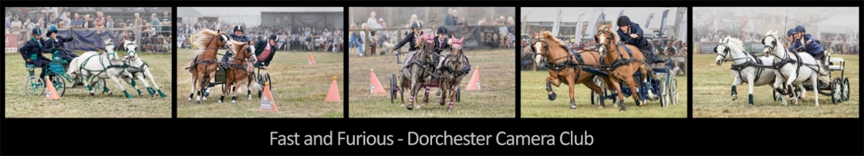

Digital images must be in jpeg format at a maximum size of 1600 x 1200 pixels.
Name each digital image file with a prefix from 1 to 5 (or 3) in panel order, underscore, Title, underscore, Photographers Name and Distinctions (e.g., "3_Sunset over the Sea_John Smith_ARPS”).

