Council Meeting, Knightshayes Trophy Competition and Talk

West Monkton Village Hall, Monkton Heathfield, Taunton TA2 8NE

Sunday 3rd March 2024

10.30 am Council Meeting open to all WCPF Club Members followed by the
Knightshayes Trophy Competition judged by Helen Jones ARPS DPAGB
President WCPF, a double act with Stephen Jones - DPAGB, LRPS, EFIAP BPE3* Set subject “Water in all its Forms” to win the Superb Knightshayes Trophy for a year.

All WCPF Club members may enter up to TWO mounted prints, there is no Fee for entering Knightshayes and Admission on the day is Free

2.00 pm Talk “Arctica” by Pam and Eddy Lane both ARPS DPAGB EFIAP APAGB

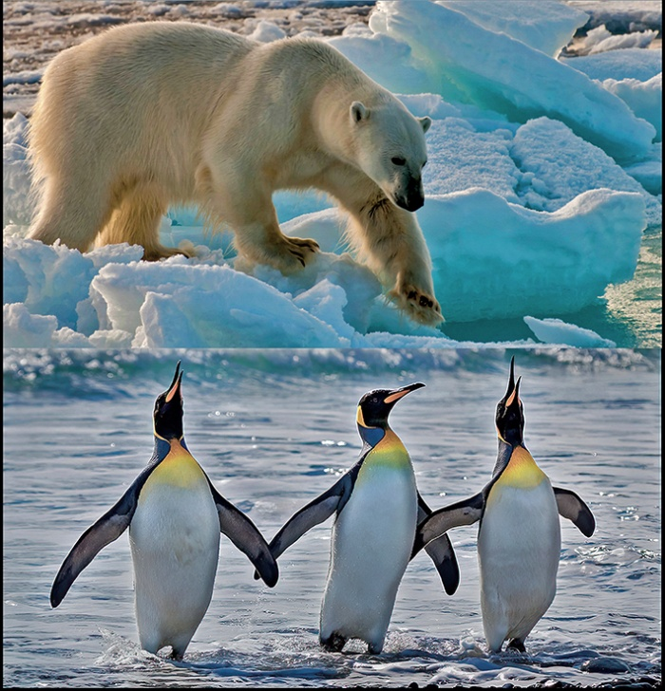

Pam and Eddy present the best moments from their multiple Expeditions to the Arctic and Antarctic over the last few years, including the Wildlife, History, Landscape and Environment of these Polar Regions. As well as Award Winning photographs, it includes Audio Visual and Video sequences that bring their experiences of these iconic regions to life. It will detail the many common features, but also the very surprising differences of two huge continents literally Poles Apart
Knightshayes Trophy 2024 Entry Form

Set Subject “Water in all its Forms”

This completed Form to be submitted with your prints

WCPF Club Members may enter a maximum of TWO PRINTS - Hand in
prints Sunday 4th February 2024 at the Exeter Corn Exchange Inter-Club Championships or pass to any WCPF Exec member prior to that

THERE IS NO FEE FOR ENTERING PRINTS

Simple Rules – prints must be mounted on 50 x 40 cm card, labelled on
Reverse with Title, Author’s Name Distinctions and Club

Name and Distinctions

Club

Tel

E-mail

Title Print 1
___________________________________________________________________

Title Print 2

Please arrange for your prints to be collected at the end of event!

Queries - Contact Pam and Eddy Lane, Knightshayes Trophy Secretaries
at - knightshayes.wcpf@gmail.com

