2025 Kingswood Salver and Lanes Trophy
Saturday 15th November 2025
Judging and afternoon Talk at Clyst St Mary Village Hall,
Clyst St Mary, Exeter, EX5 1AA
10.30 am for 11.00 am Start  Talk 2.00 pm - Close 4.00 pm | Awards for Best Panels &  Best Individual Prints
Closing Date for Prints at AGM Saturday 11th October 2025
Entry Fee £15 per club for the Salver and £10 per Club for the Lanes Trophy payable to WCPF. Bank details are
Sort Code 40-34-39 Account 31158139 - Ref Club Name

Admittance Fee £5 CASH at the Door

The Judge and Speaker will be Les Loosemore AWPF DPAGB. Les is an experienced Judge and Speaker, a prolific photographer and a Fotospeed Ambassador
There are two separate panel competitions for WCPF clubs.
- The ‘Kingswood Salver’ that is for a panel of 5 prints on a theme.
- The ‘Lanes Trophy’ is for a panel of 3 prints on a theme.
For both competitions each print entered must be from a different photographer who is a current member of the club submitting the panel.
A club may only enter one of the competitions. Any club that has previously been placed in the Kingswood Salver competition must continue to enter the Salver. The Lanes trophy is aimed at clubs that have never previously entered a panel or that are a small club and therefore have difficulty in sourcing prints from 5 different members.
The Trophies are awarded to the winning club in their respective competitions. Individual awards will be selected from all prints entered, ie both competitions. The Vivien Croucher Memorial Plate will be awarded to the best print, and the judge will select 2nd and 3rd places, plus several Highly Commended prints.

Entries and Winners will be displayed on the WCPF website and Facebook Page. Entries from previous years can be seen on the Kingswood Salver page of the WCPF website.

Entry Information

Each entry must be 50cm x 40cm mounted prints, 5 for the Kingswood Salver and 3 for the Lanes Trophy. They can be Colour, Mono, or Both. They will be judged as a panel.
Prints must be from different photographers. Members may only submit a print for one club, and Clubs are only allowed to make one entry.
Label your mounted prints on the reverse with a number indicating panel order (left to right), Title and Photographer details as entered on the form below and club name.
Deliver your labelled Prints at the WCPF AGM on 11th October or give to any WCPF Exec member by 10th October. Include a copy of your entry form.
Email kingswood.wcpf@gmail.com copying sandiecox@btinternet.com no later than 11th October 2025 with your completed Entry Form, digital copies of the prints, plus a digital montage of the entire panel. Include your panel title on the digital montage (for an example, see below).

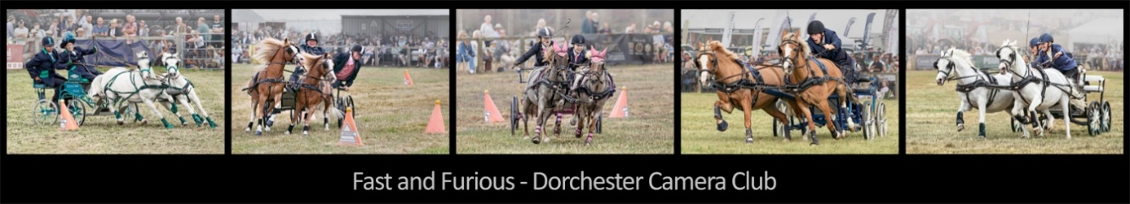

Digital images must be in jpeg format at a maximum size of 1600 x 1200 pixels.
Name each digital image file with a prefix from 1 to 5 (or 3) in panel order, underscore, Title, underscore, Photographers Name and Distinctions (e.g., "3_Sunset over the Sea_John Smith”).

2025 Kingswood Salver/Lanes Trophy Entry Form

Competition: Kingswood Salver/Lanes Trophy (Delete as applicable)
Club Name: (Club must be current WCPF Member)
Contact name:
Contact e-mail: Phone Number:
Panel Title:
Print | Print Title | Photographer/Distinctions  (Full Name please)
1
2
3
4
5

You will be sent confirmation of receipt of your entry form
PLEASE arrange for your Panel to be collected after the judging on 15th November

